|  |  |
| --- | --- |
|  | |
| WEDE5020 POE Part 1 | |
| Student Number: | ST10438420 |
| Programme Code: | HMAW0501 |
| Module Lecturer: | Courteney Young |
| Module Code: | WEDE5020 |
| Date of Submission: | 15-08-2024 |

|  |
| --- |
| I hereby declare that I did not plagiarise the content of this assignment and that this is my own work.  Assignment submitted via SafeAssign: (Tick the Box) |

Table of Contents

1 Website Idea 2

2 Research and Assets 3

3 Website pages and Content 4

4 Reference List 5

# Website Idea

The following is a non-profit tattoo pallor idea, this initiative is set in place too help aspiring artists in the poor communities who do not have outlets to help them improve in their dreams when it comes to art and their way of expressing themselves through the media.

Why you chose the idea

As an aspiring artist who is still wants to reach the pinnacle of art and using it as a form of expression, that’s very close to home. We never got opportunities from external outlets, organisations so by providing what I didn’t have I hope that more youths will grasp the opportunity and make the best of it.

* Home Page: The Home Page of the website is the introduction to the idea of what we trying to accomplish it sets the standard for our vision.
* Art Gallery: The art gallery is the work of previous youths who got to meet our sponsors as their work was exemplary, setting the standard of the work and creativity new members need to achieve.
* Projects: The Projects is our way of supporting the communities we inhabit in with our out-reach programmes from donating food to essential needs we can provide.
* About Us: This the Page where you’ll find more information about the people who work hard all in the name of improving our community.
* Contact Us: All our essential information you will need to get in touch with us.

# Research and Assets

Logo

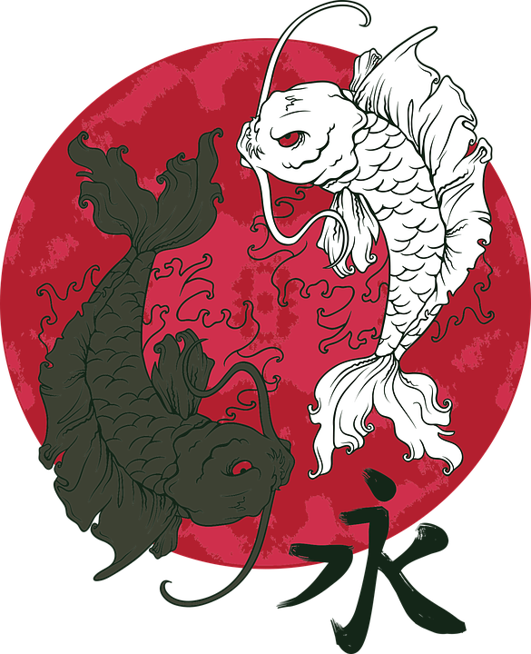

CMI prides itself on delivering the best, exceptional work, as artist we tell stories through our art bringing forth the stories our clients want to express.

Stories of hardships, triumphant victories and memorable losses all of these are told through the pictures/art we paint.

## Artist

We currently have a selection of promising artist at our disposal, these youths are in the process of improving their lives through learning to work with other people, learning to better themselves by exposing themselves to different art styles.

Art Styles

Art Styles are the essence of what a tattoo artist is, your work is rooted in what you know best. In the world of tattooing there a plethora of art stiles from. Japanese style tattooing to black and grey.

Home Page images

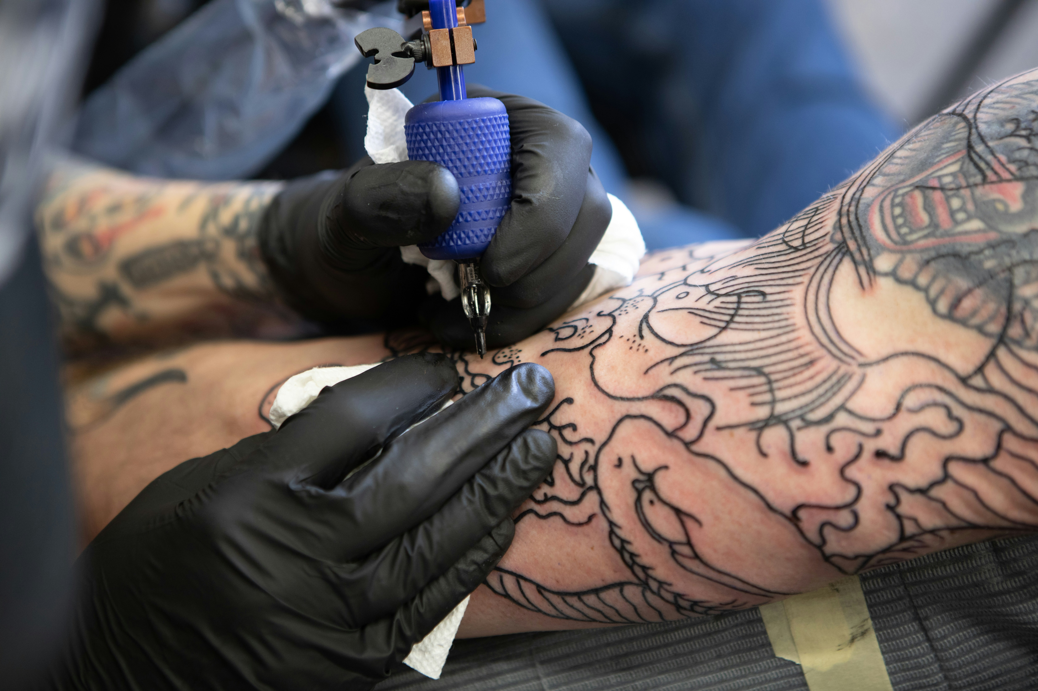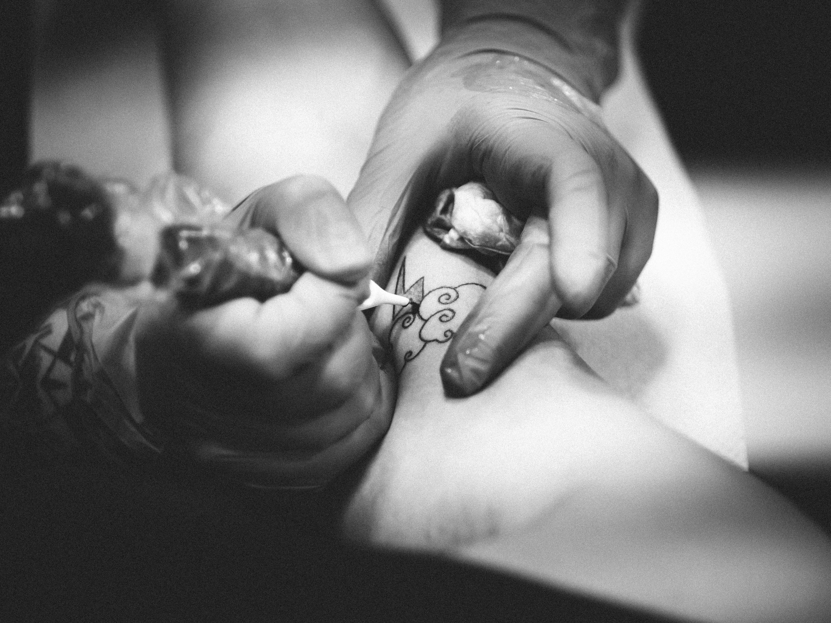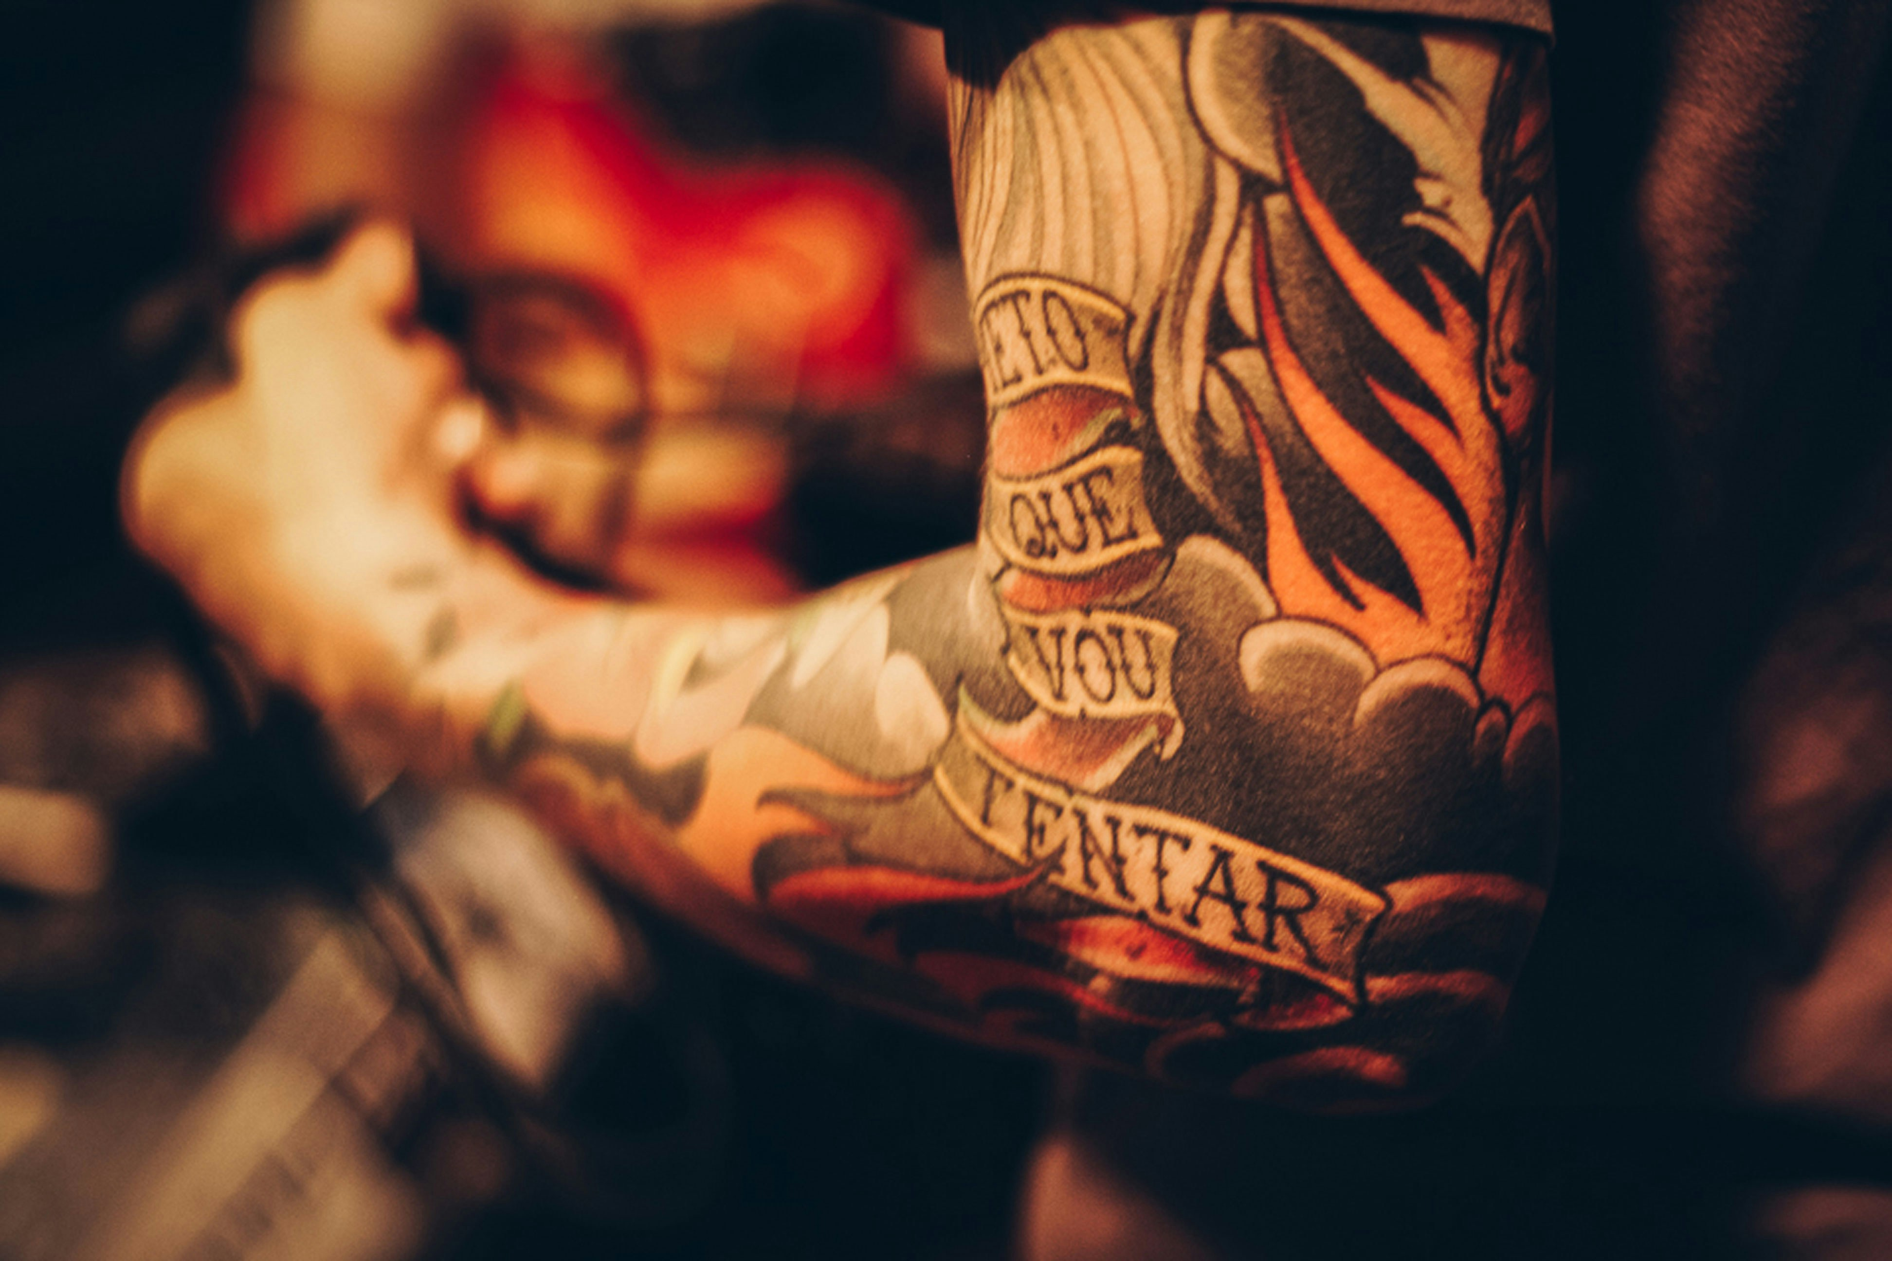

Art Gallery

# Logo



Art



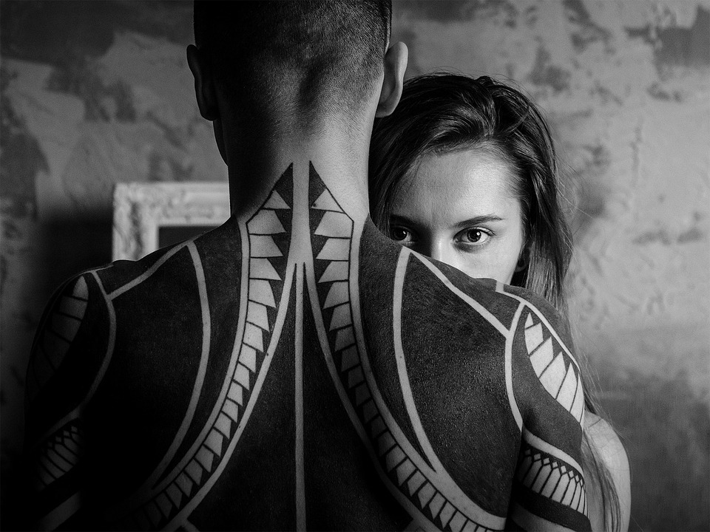

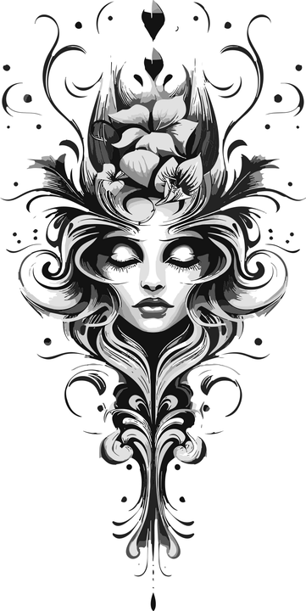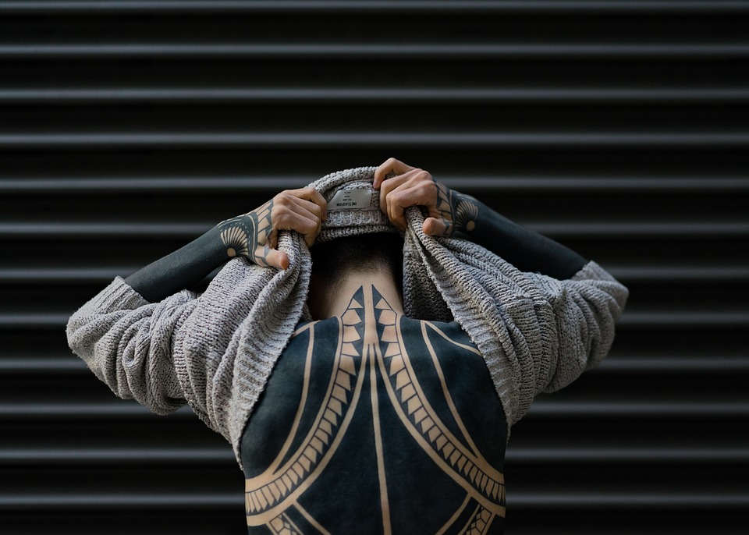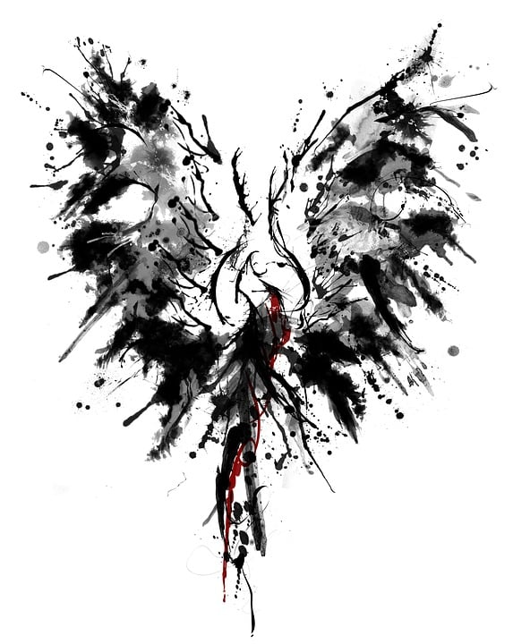

Projects/Our Work

Logo



# History

Since our start-up in 2010 we have established ourselves in the Community assisting up and coming artists we offer paid internships that last up to a year, if the artist proves themselves, we grant them access to our networking introducing them to our sponsors.

Outreach Program

We also help with the less fortunate in and around our neighbourhoods. With helping hands our studio along with our sponsors are helping better our communities putting our community first.

Contact US

LOGO



# WELCOME TO OUR INFO page

If you have any questions relating to our work, please contact us on the following. You can also contact us through our social media pages.

Contact Us

# Website pages and Content

1. Homepage
2. Our Goal
3. Tattoo History
4. Brief Tattoo Meanings
5. Koi Fish Tattoo
6. Samurai Tengu Tattoo
7. About Us
8. About Cresent Tattoo Inks
9. Our Vision
10. History
11. Goals
12. Projects
13. Tattoo Internship
14. Volunteer Work
15. Art Gallery
16. Art Gallery
17. Contact Us
18. Contact Information
19. Open Hours
20. Get in Touch
21. Our Location

# Reference List

‌Freepik. (2020). Free Vector | Vintage tattoo monochrome badge. [online] Available at:https//www.freepik.com/free-vector/vintage-tattoo-monochrome-badge_8084504.htm#fromView=search&page=3&position=37&uuid=9075c56d-f866-48d4-b352-b5ed3dd68af2Accessed 7 Nov. 2024].

Kevin Powell (2024). A practical guide to responsive web design. [online] YouTube. Available at: <https://www.youtube.com/watch?v=x4u1yp3Msao> [Accessed 7 Nov. 2024].

Lineberry, C. and Anderson, S. (2007). The Worldwide History of Tattoos. [online] Smithsonian Magazine. Available at: [https://www.smithsonianmag.com/history/tattoos-worldwide-history-144038580/.](https://www.smithsonianmag.com/history/tattoos-worldwide-history-144038580/.  )

Slaying The Dragon (2022). Learn Flexbox CSS in 8 minutes. YouTube. Available at: <https://www.youtube.com/watch?v=phWxA89Dy94.>

‌

w3newbie (2018). Bootstrap 4 Carousel Image Slider - HTML5 and CSS3 Tutorial. [online] YouTube. Available at: <https://www.youtube.com/watch?v=NxBmveFJzjY [Accessed 7 Nov. 2024].>

‌www.youtube.com. (n.d.). HOW TO TATTOO LINES ON FAKE SKIN. [online] Available at: <https://www.youtube.com/shorts/dewnwyrPTY0> [Accessed 7 Nov. 2024].

‌